**Graphing Straight Lines**

We can represent any straight line on a graph using the equation y = mx + c. This may seem complex and unintuitive at first, but this article will guide you through the basics of graphing straight lines step by step.

**The slope-intercept form**

The slope-intercept form is one of many forms of expressing the equation of a straight line. The slope-intercept form is :

$y=mx+c$, where;

* m is the slope/gradient of the line (how steep it is).
* c is the y-intercept (where the line crosses the y-axis).

The slope-intercept form is convenient when we want to determine points that lie on a given straight line. Any pair of (x,y) values that satisfies the equation of a straight line are points that lie on the line.

**Gradient/slope(m)**

The slope tells us how steep the line is. The larger the magnitude of the slope the larger the steepness. A positive slope means the line goes up as it moves from left to right (increasing). A negative slope means it goes down (decreasing).

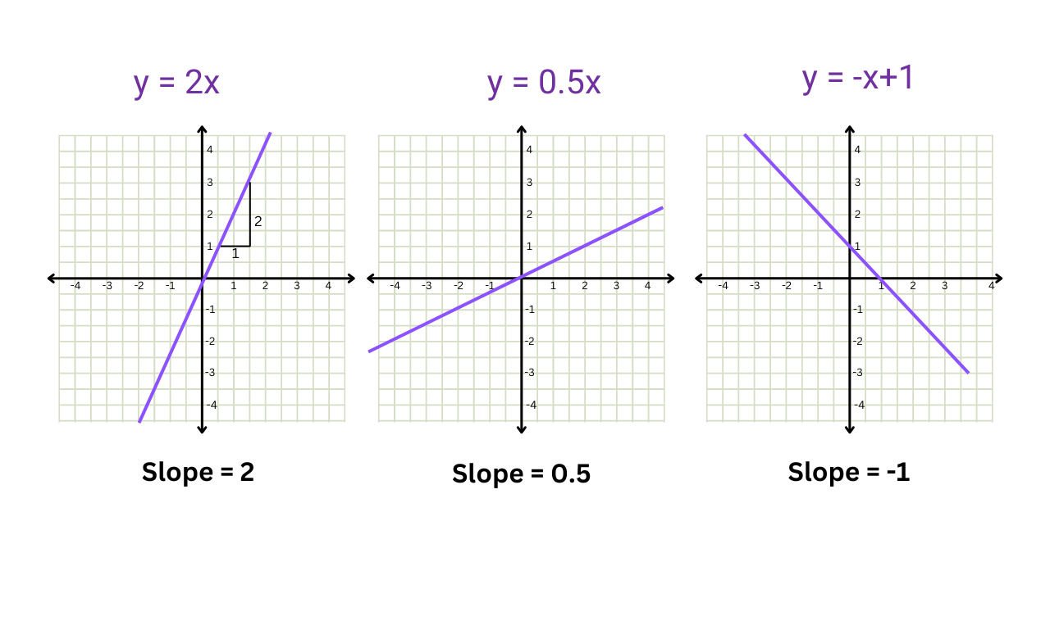

Now you should be able to visualize the general direction of a straight line based on its slope (the

m value in the line equation). However, to accurately graph a straight line, we need to consider additional features.

**Intercept(c)**

The y-intercept is the point where the line crosses the y-axis. In the equation, y = -x + 1, the y-intercept (c) is 1. This means the line crosses the y-axis at (0,1), as illustrated in the rightmost graph of the figure above. The equations y = 2x, and y = 0.5x do not have a “c” value, hence their y-intercept is at the origin. Therefore any equation of the form y = mx will be a straight line that passes through the origin (0,0).

**Graphing straight lines using a table of values**

Now let’s plot a line for the equation y = -2x-3 step by step by using the things we have learned so far.

1. We can take the y-intercept point as our first point. For this equation, the coordinates for the intercept are (0,-3).
2. Now let’s use the equation to find a set of points that lie on the line. We’ll use a table of values like the one given below. Here we can select arbitrary values of x, and use the equation of the straight line to determine the corresponding y-coordinates. Usually, the values of x you select will be dictated by the limits of the x-axis in your graph.

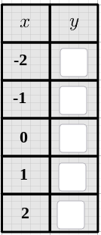

1. We can plug the x values into the equation and simplify to obtain the y-coordinates.

Let’s find the y-coordinate corresponding to the point with an x-coordinate of -2.

For x = -2,

$y= -2(-2)-3$

$y= 4-3$

$y= 1$

This process can be repeated to fill the entire table of values.

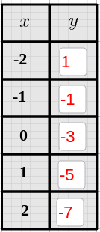

1. Finally, we can mark the points we generated on a coordinate plane and plot the straight line.

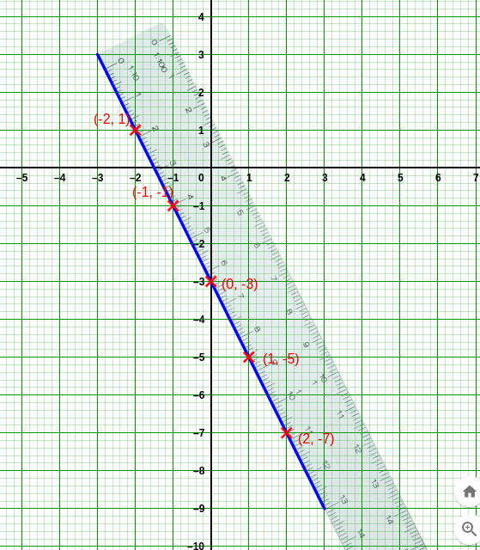

It is a good practice to verify that the straight line we have plotted is accurate by analyzing the properties like the slope and y-intercept discussed earlier. The direction of the straight line accurately reflects the negative slope of -2 in the equation hence the graph is correct.